**NAME- DEVANSHU SURANA**

**ELECTIVE ROLL NO-BT1-18**

**PANEL ROLL NO- PC-23**

**PRN-1032210755**

**PANEL-C**

**Assignment 7**

**Demonstrate setup of geth client to access Ethereum 2.0 blockchain**

**1). Aim :** Demonstrate setup of geth client to access Ethereum 02 blockchain

**2). Objectives :**

* Configure the Geth client to connect to the Ethereum 2.0 blockchain network.
* Establish a secure and synchronized connection to the Ethereum 2.0 network using Geth.
* Validate successful interaction with the Ethereum 2.0 blockchain through Geth commands.

**3). Theory :**

**4). Implementation :**

**4.1).** Download and install geth for Windows from the site <https://geth.ethereum.org/downloads> :

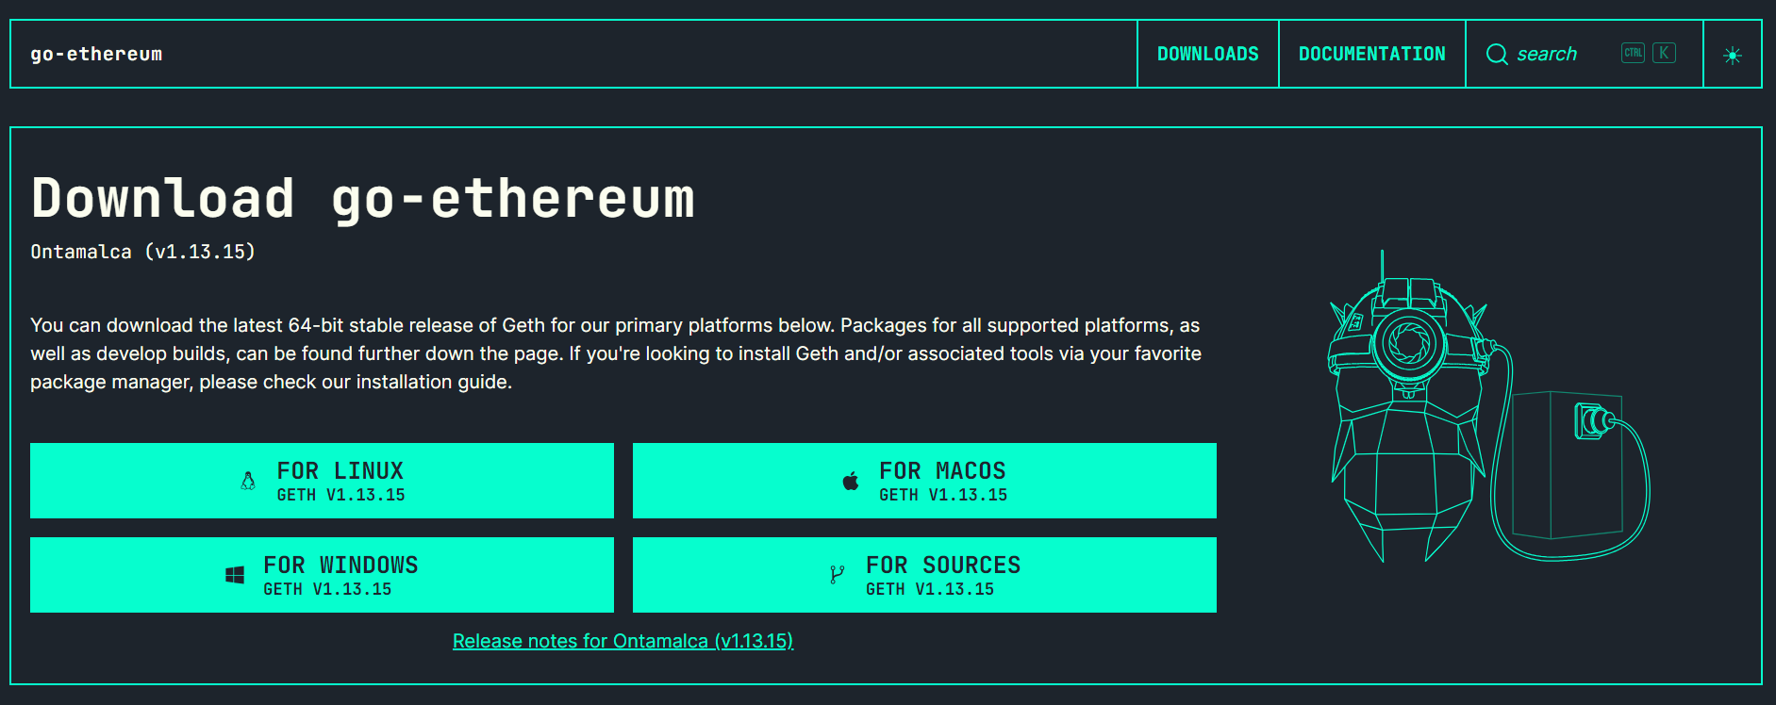

Fig 4.1). Homepage of geth.ethereum.org

* Download zip file
* Extract geth.exe from zip
* Open a command prompt
* Execute geth.exe

**4.2).** Run geth :

In order to spin up a Geth node, the only thing you need to do is go to your terminal window and run **geth** .

➜ ~ geth

INFO [06-03|11:03:13] Maximum peer count ETH=25 LES=0 total=25

INFO [06-03|11:03:13] Starting peer-to-peer node instance=Geth/v1.8.10-stable/darwin-md64/go1.10.2

INFO [06-03|11:03:13] Allocated cache and file handles database=/Users/mjvr/Library/Ethereum/geth/chaindata cache=768 handles=128

INFO [06-03|11:03:13] Writing default main-net genesis block

INFO [06-03|11:03:14] Persisted trie from memory database nodes=12356 size=2.34mB time=48.31016ms gcnodes=0 gcsize=0.00B gctime=0s livenodes=1 livesize=0.00B

INFO [06-03|11:03:14] Initialised chain configuration config="{ChainID: 1 Homestead: 1150000 DAO: 1920000 DAOSupport: true EIP150: 2463000 EIP155: 2675000 EIP158: 2675000 Byzantium: 4370000 Constantinople: <nil> Engine: ethash}"

INFO [06-03|11:03:14] Disk storage enabled for ethash caches dir=/Users/mjvr/Library/Ethereum/geth/ethash count=3

INFO [06-03|11:03:14] Disk storage enabled for ethash DAGs dir=/Users/mjvr/.ethash count=2

INFO [06-03|11:03:14] Initialising Ethereum protocol versions="[63 62]" network=1

INFO [06-03|11:03:14] Loaded most recent local header number=0 hash=d4e567…cb8fa3 td=17179869184

INFO [06-03|11:03:14] Loaded most recent local full block number=0 hash=d4e567…cb8fa3 td=17179869184

INFO [06-03|11:03:14] Loaded most recent local fast block number=0 hash=d4e567…cb8fa3 td=17179869184

INFO [06-03|11:03:14] Regenerated local transaction journal transactions=0 accounts=0

INFO [06-03|11:03:14] Starting P2P networking

INFO [06-03|11:03:16] UDP listener up self=enode://a4cb08519bc2bceecb8ad421871c624d5212888653bbaee309fda960f3c87ca7aa9855ee14684d521836ae88ad1986b8ca944348e976760d2bd1247ed3ca7628@[::]:30303

INFO [06-03|11:03:16] RLPx listener up self=enode://a4cb08519bc2bceecb8ad421871c624d5212888653bbaee309fda960f3c87ca7aa9855ee14684d521836ae88ad1986b8ca944348e976760d2bd1247ed3ca7628@[::]:30303

INFO [06-03|11:03:16] IPC endpoint opened url=/Users/mjvr/Library/Ethereum/geth.ipc

Fig 4.2). Output on running the “geth” command in the terminal

* After this, you should see new lines appear periodically, where Geth says “Importing new state” or “Importing new block headers” or “Importing new receipts”.
* The state, block headers and transactions are part of [Ethereum’s tree tries](https://ethereum.stackexchange.com/questions/15142/how-many-tries-does-ethereum-have): they must be downloaded in order to synchronize your node with the Ethereum blockchain.

**4.3).** Accessing a Geth console

Now that you’ve created a node, you can access it by opening up a new tab in your terminal and running the following:

**geth attach**

This will connect a Geth console — which is a Javascript environment for communicating with the blockchain — to your running node. This can be done in both the full client mode and the light mode.

After you’ve opened the console, type this:

**web3.eth.blockNumber**

You should get an output as a number (e.g. 5631487) which represents the current block number of the Ethereum network.

**4.4).** Creating a new account :

In order to use the blockchain, you need to have an account. With Geth, you can do it by running the following in your terminal:

**geth account new**

- After you’ve done that, it will ask you for the password, which you’ll need to protect your account. Make sure to use a secure password and to store it safely.

- What Geth does when you run geth account new is update a file in the Geth data directory (a directory where Geth stores all the necessary data, including blocks and headers).

* The locations are (per platform):

- macOS: ~/Library/Ethereum

- Linux: ~/.ethereum

- Windows: %APPDATA%\Ethereum

**5). FAQs :**

1. What are the key steps involved in configuring the Geth client to connect to the Ethereum 2.0 blockchain network?

* Download and install Geth from the official Ethereum website or via package managers.
* Specify parameters such as network ID, data directory, and RPC endpoint during configuration.
* Configure Geth to connect to the Ethereum 2.0 blockchain network, specifying the appropriate network settings.
* Ensure synchronization with the Ethereum 2.0 blockchain by allowing Geth to download and verify the blockchain data.
* Verify successful connection and interaction by executing commands or transactions via Geth on the Ethereum 2.0 network.

1. How does one ensure the security of their connection when setting up Geth to interact with Ethereum 2.0?

* Implement authentication mechanisms to control access to Geth and its functionalities.
* Set up firewall rules to restrict unauthorized access to Geth's network ports and prevent potential attacks.
* Regularly update Geth to the latest version to patch security vulnerabilities and ensure compatibility with the Ethereum 2.0 network.
* Utilize secure communication protocols such as HTTPS for remote procedure calls (RPC) to protect data transmission between Geth and other applications.
* Implement best practices for key management, such as using hardware wallets or secure key storage solutions, to safeguard private keys used for transactions and interactions with Ethereum 2.0.

1. What are some common challenges users might encounter when attempting to synchronize their Geth client with the Ethereum 2.0 blockchain, and how can these challenges be overcome?

* Network Congestion: High network traffic can slow down synchronization. Users can overcome this by selecting off-peak hours for synchronization or using alternative synchronization methods like fast sync.
* Disk Space: Ethereum 2.0 blockchain data can be large, requiring significant disk space. Users may need to allocate more storage or consider pruning options to manage disk space efficiently.
* Hardware Requirements: Synchronizing Ethereum 2.0 blockchain demands substantial computational resources. Users encountering performance issues may need to upgrade their hardware or optimize Geth settings for better performance.
* Connection Issues: Intermittent internet connectivity or network disruptions can interrupt synchronization. Users can ensure a stable connection and retry synchronization, or use alternative synchronization methods like light client mode.

1. What are the primary commands or functionalities within Geth that users can utilize to interact with the Ethereum 2.0 blockchain once the setup is complete?

* eth: Provides Ethereum-related functionalities including account management, transaction processing, and smart contract interaction.
* net: Offers network-related functionalities such as peer management, network status, and connectivity information.
* admin: Allows administrative tasks like managing Geth's configuration, starting and stopping the client, and adding or removing peers.
* debug: Provides debugging functionalities for troubleshooting and diagnosing issues within Geth and the Ethereum 2.0 blockchain.
* miner: Enables mining operations for users interested in participating in Ethereum 2.0's proof-of-stake consensus mechanism.
* txpool: Manages the transaction pool, allowing users to view pending transactions, prioritize transactions, or clear the pool if necessary.

**6). Conclusion :**

In conclusion, through this demonstration, we have successfully set up the Geth client to access the Ethereum 2.0 blockchain network. By following the outlined steps, users can confidently connect to and interact with Ethereum 2.0 using Geth, facilitating their participation in this innovative blockchain ecosystem.